Gender Ideology

Name
Affiliation
Date

Gender Ideology
Women of the Middle Ages and the renaissance women were denied all political rights and considered legal subjects. Such women were expected to perform the duties of a housewife. The majority of peasant women worked in the fields alongside their husbands and later ran the home. The wives of the middle-class shop owners were expected to run their husband’s businesses well. Although servants served the women of the highest class, they were also engaged in their household tasks such as entertaining, cooking and sewing.
The unmarried women were not allowed to live independently, and, in most cases, they lived in the houses of their male relatives. Few wealthy women were able to break the norm of subjugation to attain minor fame. an example of such a woman is Lucrezia Borgia, the daughter of pope alexander VI. Pope alexander tried to use Lucrezia as a pawn in his political moves. to progress in his political ambitions, he arranged marriage to Giovanni Sforza when she was 13. after four years, he no longer needed Sforza for political support. The father and nullified the marriage after spreading false accusations of Giovanni's impotence. Alexander Vi then married Lucrezia to the illegitimate son of Naples king. In the year 1502, Lucrezia was divorced and married again and remarried (Richardson, 2020).
The central theme of the life of renaissance women was subjugation. From childhood and later on, women were controlled by their parents and later on handed into the husbands’ hands. in all cases, a husband was most likely not her choice and would control her until her death. Women who remained unmarried received no independence of action and thought since they lived under subjugation in a Covent or homes of a male relative.
A convent converted such women into nuns, which was the only career accessible by the female gender. The women were frequently discouraged from participating in sciences or arts. Thus the universe the world will ever know the full literacy and artistic potential of the renaissance age .only women of the highest class and rank were given a chance to differentiate themselves. Such an aspect was rare as, for the most part, women were supposed to entertain, cook and sew. in history, women-only provided a backdrop to the social and political story of the Renaissance. For instance, there is little written about women in the medical line (Hartt & Wilkins, 2011).
Another renaissance woman is properly de Rossi, who lived from 1490 to 1530 when the woman artist was unrecognized. De Rossi lived in Italy, where profound artists surrounded her. She was a unique woman since she made religious sculptures. Properzia also produced free-standing sculptures and relief sepultures that impacted her artistic life in the Renaissance and women ("Properzia de Rossi,"). The artist lived a pretty remarkable life as she was the first female Italian artist in the 16th century art period. After attending college to better her skills, she outdid the majority of male artists, for example, Joseph, who was forced to run off. Some statues in Italy on display were rare for a women artist's work to be explicitly displayed during the renaissance period (Quin, 2012).
This age was also filled with spiritual wordiness, which became evident in visual art. however, little is known about female artists of the renaissance period. Infrequently tiny pieces of sculptures attributed to the de Rossi appear at auction and some in the Bologna churches. Unfortunately, there is no comprehensive list of de Rossi sculptures; her role as a female-led the path for other women to do more than be homemakers. De Rossi proved that women could also carve art pieces. The artist also proved that women could curve art for religious purposes. She served as an inspiration to many other women as she kept trying to prove women's capabilities ("Vittoria Colonna in Giorgio Vasari’s “Life of Properzia de’ Rossi”," 2016).
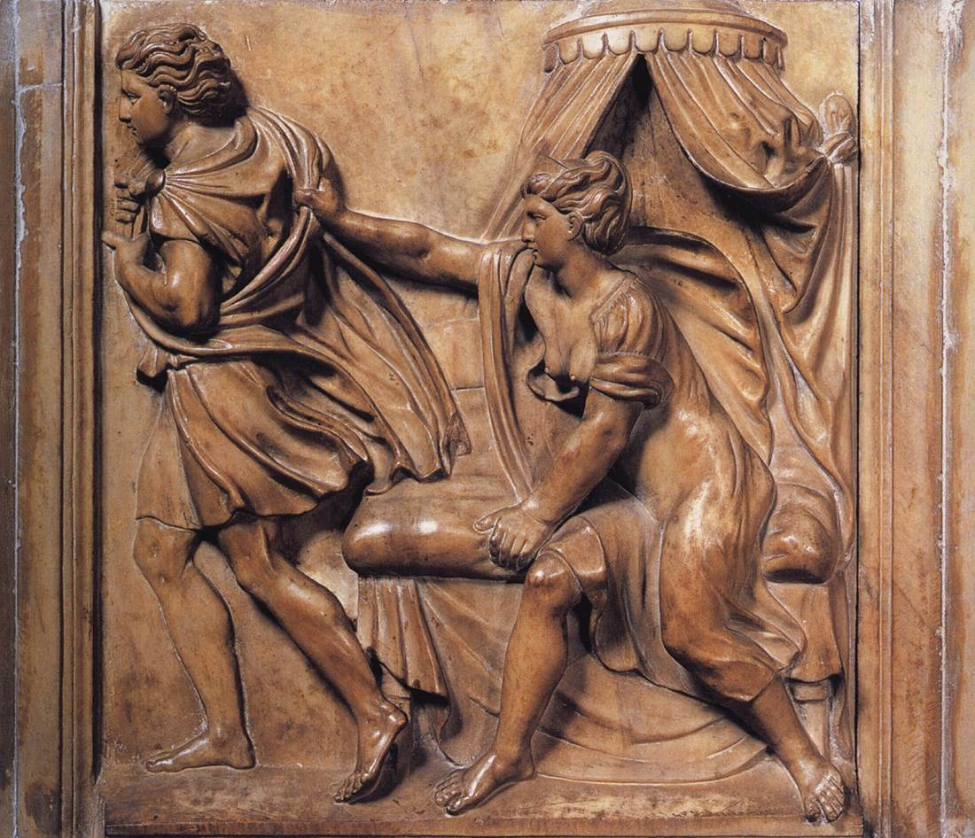
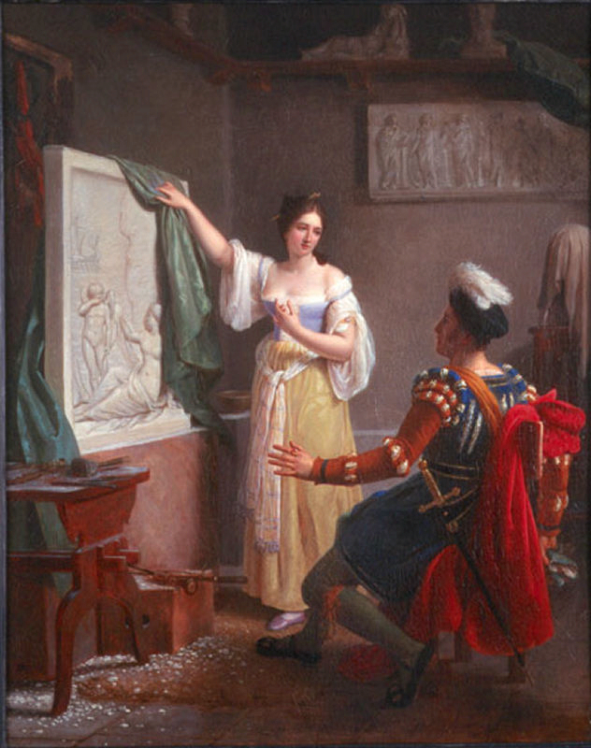
Joseph And Potiphar’s wife (1525-26) Louis Ducis (1822)
De Rossi had an intellect for both same dept and capricious she set herself to carve stones. Properzia carved her arts in patience that they were marvelous and singular to behold for the subtlety of the work and the liveliness of the little figures she made. One of the most attributed sculptures is joseph and Potiphar’s wife. The sculpture base depicts the biblical story in which joseph escapes the seductive Potiphar’s wife properly is distinguished as one of the females who afforded extended analysis in Giorgio Vasari’s edition. Majority of Properzia's artwork aligned with the derogatory assumptions about female nature.
Lavinia Fontana (1552-1614) and sofonisba Anguissola were usually encouraged by their relatives to pursue careers as painters. Sonfonisba hailed from the northern Italian town Cremona which was under Spanish influence. Sofsonisba was born in the 1530s in a family that claimed to be noble descendants of Carthaginians and were wealthy to send their two oldest daughters to learn how to paint. However, sofonisba parents were not well-off to send her to study her artistic gift. She left Italy, and by 1959 she was already established as a portraitist in her way. Painting offered her a platform to achieve a social position appropriate to her relatives. Her personality and abilities, combined with her father's skills, led her to become a woman with renowned virtues, furthering the possibilities of women in artistic roles and becoming a legendary figure.
Fontana, a painter of prestige, was encouraged by the paintings of the natural environment, and his father offered her an art career. Lavinia Fontana was the first female painter acknowledged as an artist and professional who transcended the pictorial and limits imposed on women. Her remarkable works include private oratories and religious work for churches. Fontana and sofonisba were female pioneers of painting who achieved recognition and fame among their contemporaries. The female painters pull to pieces the social stereotypes assigned to women about the artistic practice and the skepticism about their capabilities.
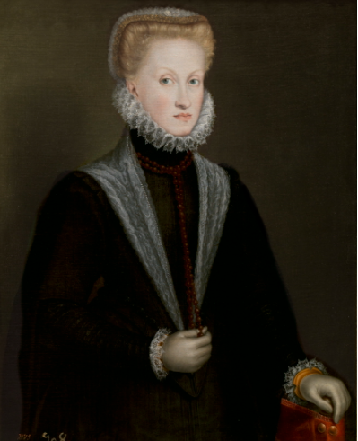

Queen Anne of Australia (1573)
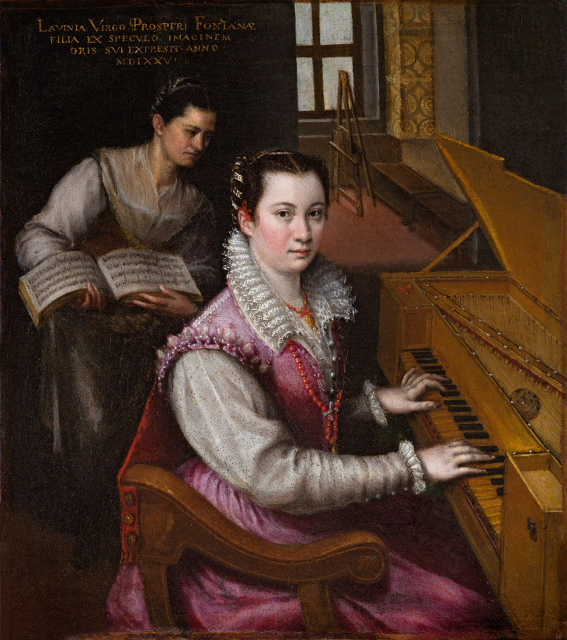

Self-portrait at the spinet (1577)
The guerrilla girls are fighting the exact cause that is discrimination in the art world. The majority of artwork discriminates against people of color and women, similar to the renaissance period. The feminist activist artists have been fighting such discrimination for decades now. They came together with a reaction to the international survey of painting and sculptures (Stein, 2011). The activists claim that out of 169 artists, only 13 were women, and they came from Europe or the United States. The guerrilla girls employ cultural jamming in public appearances, billboards, books, and posters to expose corruption and discrimination. After several decades the guerrilla girls have enjoyed a victory lap. Recently the Whitney Museum of American art acquired the group’s portfolio of 88 ephemera and posters from 1985 to 2012 documenting the number of minorities and women represented in institutions and galleries. The walker art center in Minneapolis also bought the girls' entire collection of posters in numbered prints.

References
Hartt, F., & Wilkins, D. G. (2011). History of Italian Renaissance art: Painting, sculpture, architecture. Pearson College Division.
Properzia de Rossi. (n.d.). prezi.com. https://prezi.com/towxsu_gmndg/properzia-de-rossi/
Quin, S. (2012). Describing the female sculptor in early modern Italy: An analysis of the vita of Properzia de' Rossi in Giorgio Vasari's lives. Gender & History, 24(1), 134-149. https://doi.org/10.1111/j.1468-0424.2011.01672.x
Richardson, B. (2020). Women and the circulation of texts in Renaissance Italy. Cambridge University Press.
Stein, G. (2011). Guerrilla girls and guerrilla girls broadband: Inside story. Art Journal, 70(2), 88-101. https://doi.org/10.1080/00043249.2011.10791003
Vittoria Colonna in Giorgio Vasari’s “Life of Properzia de’ Rossi”. (2016). Wives, Widows, Mistresses, and Nuns in Early Modern Italy, 137-156. https://doi.org/10.4324/9781315233918-16

